RAM

Front image

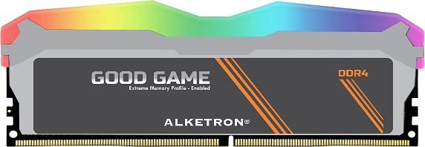

Inner

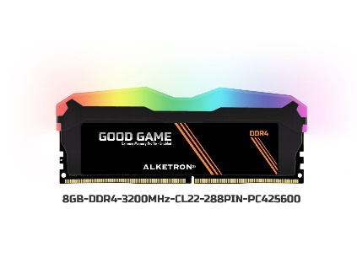

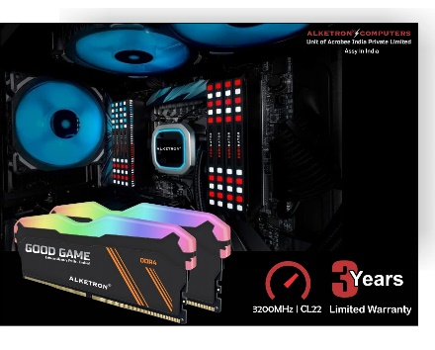

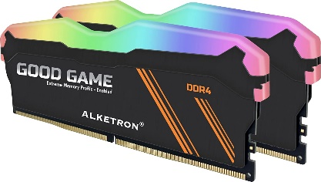



ALKETRON – 8GB DDR4 3200MHz RAM (Memory) - Quad Channel UDIMM (SDRAM) PC4-25600 for Gaming Desktop PC - with 3 Year Warranty (8GB-3200MHz - LED Gaming -...

-59% ₹3,125.00₹3,125.00

M.R.P.: ₹7,550.00₹7,550.00

**Product details**

|  |  |
| --- | --- |
| **Brand** | ALKETRON |
| **Computer Memory Size** | 8 GB |
| **RAM Memory Technology** | DDR4 |
| **Memory Speed** | 3200 MHz |
| **Compatible Devices** | Desktop |
| **Voltage** | 1.2 Volts |

* Assembled In India – ALKETRON Quantum Cache - DDR4 RAM(Memory) with LED Heat sink for relentless Gaming Experience | 3 Years Warranty | After sales services available all over India, Contact ALKETRON Computers – an Indian hardware start-up obsessed with Quality Engineering
* XMP (Extreme Memory profiling) enabled | Speeds up to 3733MT/s | kit capacities up to 128GB | Unique Diamond Cut design with RGB LED Lights for Competitive eSports & Gaming. Tested for Relentless Gaming with 3 Year Replacement Warranty by ALKETRON Computers, Bengaluru
* Capacity = 8GB | Memory Speed-3200MHz | PC4-25600 (3200MHz) | CAS latency - CL22 | Number of Channels intended to support=Quad Channel | Compatible with INTEL & AMD
* ECC Type = Non-ECC , Unbuffered | Form Factor = UDIMM | Pin Count = 288-pin| Voltage = 1.2V; Rank and Configuration = 1Rx8
* Competitive eSports Gaming Memory Developed by ALKETRON Computers. Please contact ALKETRON support for compatibility and warranty related information

.